**Security Architecture Recommendations Report for e-Commerce Company**

**Executive Summary**

In this comprehensive report, we address the urgent need to enhance the cybersecurity infrastructure of the e-Commerce company. Currently faced with significant vulnerabilities such as an unsegmented network, outdated authentication measures, inadequate data protection, and inconsistent endpoint security, the company is at increased risk of cyber threats. To counter these vulnerabilities, we propose strategic improvements aligned with the NIST Cybersecurity Framework, focusing on implementing robust access control, enhancing data security through encryption, segmenting the network, and advancing endpoint protection.

A phased implementation strategy is recommended to ensure effectiveness and minimal operational disruption, beginning with network segmentation and culminating in continuous monitoring and incident response. These measures are critical not only for securing the company's digital assets but also for maintaining customer trust and ensuring compliance with regulatory standards. By prioritizing cybersecurity, the e-Commerce company will fortify its defenses against current and future cyber threats, thereby supporting sustainable growth and strengthening its competitive position in the digital marketplace. This executive summary underscores the necessity of these enhancements and calls on executive leadership to commit the necessary resources towards this vital initiative.

**Section 1: Introduction**

This report is prepared as a critical component of our ongoing cybersecurity improvement initiative at e-Commerce Company. It details a series of proposed upgrades designed to bolster our defenses and ensure the integrity and availability of our digital assets.

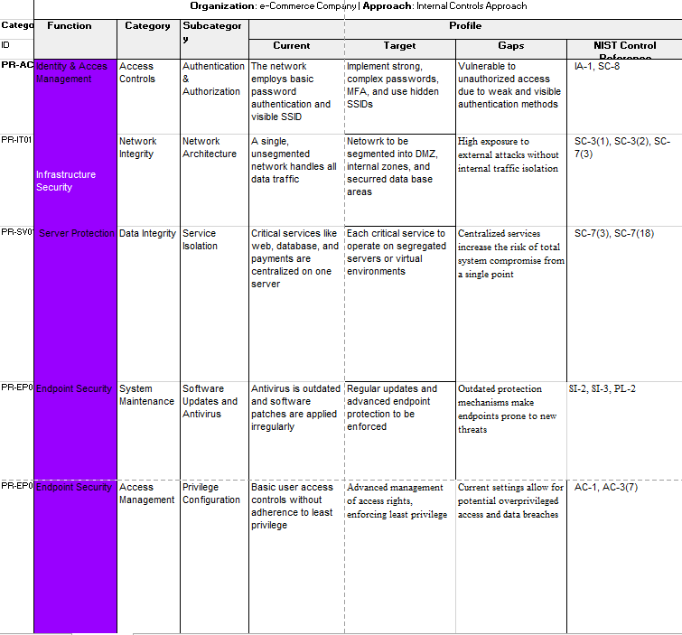

**Section 2: Current Security Landscape**

**Overview**

This section provides a comprehensive analysis of the current cybersecurity infrastructure and identifies key vulnerabilities that could potentially compromise the integrity and security of the e-Commerce platform.

**1. Network Structure and Vulnerabilities**

- The entire network operates on a single, unsegmented structure, exposing sensitive systems to potential breaches from any network entry point. This configuration lacks necessary internal safeguards, such as firewalls or intrusion detection systems, between different segments of the network.

- A breach in one area can quickly spread to other parts of the network, compromising critical data and operational systems.

- High probability of widespread system compromises from single points of attack, leading to potential data theft, service disruptions, and loss of customer trust.

**2. Access Control Weaknesses**

- Current access controls rely solely on usernames and passwords. This method is susceptible to a variety of attacks such as phishing, brute force, and credential stuffing.

- The absence of MFA means that access is granted based solely on knowledge of username and password, without any additional verification steps to confirm the identity of users accessing the system.

- Increased risk of unauthorized access to sensitive areas of the network, leading to data breaches and unauthorized activities.

- Medium to high risk of unauthorized access, especially given the increasing sophistication of cyber-attacks.

**3. Endpoint Security Challenges**

- Endpoints including workstations and mobile devices are protected by antivirus software that is not regularly updated. Many devices also lag in receiving critical security patches.

- Outdated antivirus software and unpatched systems are vulnerable to malware, ransomware, and other malicious software exploits, which could bypass existing defenses.

- High risk of endpoint compromise, which could serve as entry points for attackers to access the corporate network.

**4.** **Visibility of Sensitive Systems**

- Sensitive systems such as payment gateways and customer databases are accessible through the main network without adequate security measures to isolate and protect these critical assets.

- The visibility and accessibility of these systems from any part of the network make them attractive targets for cyber-attacks.

- High risk of targeted attacks aimed at stealing sensitive financial and personal data.

**Section 3: Security Architecture Goals**

**Overview**

This section delineates strategic goals to enhance the cybersecurity architecture of the e-Commerce company. The objectives are designed to mitigate identified vulnerabilities and prepare the network for scalable and secure operations.

**1. Implement Advanced Authentication Mechanisms**

- Introduce multi-factor authentication (MFA) across all user and administrator accounts to significantly enhance identity verification processes.

- MFA adds an additional layer of security by requiring two or more verification factors, which significantly reduces the risk of unauthorized access through compromised passwords.

-Implementation of MFA will drastically decrease the likelihood of security breaches originating from stolen or weak credentials, thus safeguarding sensitive customer and business data.

**2. Adopt Robust Encryption Methods**

- Encrypt sensitive data both at rest and in transit to ensure its confidentiality and integrity.

- Encryption protects sensitive data from unauthorized access and data breaches, even if other security measures fail.

- With robust encryption, the company ensures that sensitive data such as customer information, payment details, and business insights remain protected against interception and exploitation.

**3.** **Upgrade Network Architecture**

-ransition from a single, unsegmented network to a segmented network architecture with clearly defined zones for sensitive operations.

- Network segmentation divides the network into multiple segments or subnetworks, each acting as a separate security domain, which limits the spread of cyber-attacks within the network.

- This approach not only improves security by containing potential breaches within isolated network zones but also enhances overall network performance and management.

**4. Implement Stringent Access Controls**

- Develop and enforce stringent access controls to manage who can access what data and from where.

- Effective access controls ensure that employees have access only to the resources necessary for their job roles, significantly reducing the risk of internal threats and data exposure.

- Proper access control policies and procedures will protect critical infrastructure and data from unauthorized access and accidental or intentional data leakage.

5. **Establish Continuous Monitoring and Response Systems**

- Set up continuous monitoring and real-time threat detection systems to actively monitor network traffic and system activities for unusual or suspicious behavior.

- Continuous monitoring enables the detection of potential security incidents as they occur, allowing for immediate response to mitigate any damage.

- Implementing these systems enhances the company’s ability to respond swiftly and effectively to threats, thereby minimizing downtime and reducing the potential for significant financial and reputational damage.

**Section 4: Security Architecture Recommendations**

**Identity and Access Management (PR-AC**)

- **Sub-category**: Authentication & Authorization

- **Current Profile**: Network employs basic password authentication with visible SSID.

- R**ecommendation**: Implement strong, complex passwords, multi-factor authentication (MFA), and hide SSID to enhance security.

- **NIST Controls**: IA-1, SC-8

**Network Integrity (PR-IT01)**

- **Sub-category:** Network Architecture

- **Current Profile**: Unsegmented network handling all data traffic.

- **Recommendation**: Segment the network into DMZ, internal zones, and secure database areas to reduce exposure to external attacks.

- **NIST Controls**: SC-3(1), SC-3(2), SC-7(3)

**Server Protection (PR-SV)**

- **Sub-category**: Data Integrity Service Isolation

- **Current Profile**: All critical services centralized on one server.

- **Recommendation**: Segregate critical services across multiple servers or virtual environments to avoid a single point of failure.

- **NIST Controls**: SC-7(3), SC-7(18)

**Endpoint Security (PR-EP)**

- **Sub-category**: Software Updates and Antivirus

- **Current Profile**: Antivirus is outdated; irregular software patches.

- **Recommendation**: Regularly update antivirus software and enforce consistent patch management.

- **NIST Controls**: SI-2, SI-3, PL-2

- **Sub-category**: Access Management Privilege Configuration

- **Current Profile:** Basic user access controls without adherence to least privilege.

- **Recommendation**: Implement advanced access management, enforcing least privilege access.

- **NIST Controls**: AC-1, AC-3(7)

**Section 5: Implementation Strategy**

**Overview**

This section describes a detailed, phased approach for implementing the cybersecurity improvements recommended earlier. This strategic deployment will ensure a systematic, controlled upgrade of security measures, minimizing disruption to business operations while maximizing security effectiveness.

**Phase 1: Network Segmentation**

- **Objective***:* To isolate critical network zones to enhance security.

- **Actions**:

- Install and configure hardware and software firewalls.

- Create VLANs to logically separate network traffic.

- **Timeline**: Q1 2025.

- **Responsible Team**: IT Infrastructure Team.

- **Key Performance Indicators**:

- Completion of network segmentation architecture.

- Verification of traffic isolation via security audits.

**Phase 2: Authentication Enhancement**

- **Objective**: To strengthen access control mechanisms.

- **Actions**:

- Deploy multi-factor authentication across all platforms.

- Update and enforce strong password policies.

- **Timeline**: Q2 2025.

- **Responsible Team**: IT Security Team.

- **Key Performance Indicators**:

- Percentage of users enrolled in MFA.

- Reduction in unauthorized access incidents.

**Phase 3: Data Encryption**

- **Objective**: To secure data at rest and in transit.

- **Actions**:

- Implement end-to-end encryption for data in transit.

- Enable full disk encryption on all servers and storage devices.

- **Timeline**: Q3 2025.

- **Responsible Team**: Data Management Team.

- **Key Performance Indicators:**

- All critical data encrypted.

- Compliance with industry encryption standards.

**Phase 4: Endpoint Security Upgrade**

- **Objective**: To update and standardize endpoint protection.

- **Actions**:

- Roll out updated antivirus software and anti-malware tools.

- Implement regular patch management schedules.

- **Timeline**: Q4 2025.

- **Responsible Team**: IT Support Team.

- **Key Performance Indicators:**

- Number of endpoints compliant with new security policies.

- Decrease in endpoint-related security breaches.

**Phase 5: Continuous Monitoring and Incident Response**

- **Objective**: To establish proactive security monitoring and rapid response capabilities.

- **Actions**:

- Set up a Security Operations Center (SOC).

- Implement a SIEM system to monitor and analyze security events in real time.

- **Timeline**: Q1 2026.

- **Responsible Team**: IT Operations Team.

- **Key Performance Indicators:**

- Operational capability of SOC.

- Response times to security incidents.

**Section 6: Conclusion**

**Overview**

This section draws together the insights and recommendations discussed throughout the report, emphasizing the critical nature of the proposed cybersecurity enhancements for the e-Commerce company. It articulates the strategic alignment of these security measures with broader business objectives and highlights the benefits of a proactive cybersecurity posture.

**Key Points**

- **Enhancing Security Posture**: The implementation of the recommended cybersecurity measures is essential not just for mitigating current vulnerabilities but also for positioning the e-Commerce company to effectively manage future cyber risks. By adopting these enhancements, the company ensures the protection of sensitive data, maintains customer trust, and safeguards its operational integrity.

- **Alignment with Business Objectives**: The strategic approach to improving cybersecurity is intrinsically linked to the company’s broader business goals. Enhanced security measures contribute directly to operational resilience, enabling the company to pursue innovation and market expansion with confidence, knowing its assets and customer data are secure.

- **Compliance and Competitive Advantage**: Implementing the NIST framework and adhering to industry best practices not only ensures compliance with regulatory requirements but also enhances the company's reputation in the marketplace. This compliance is not merely about meeting legal obligations—it's about exceeding them to gain a competitive advantage.

- **Stakeholder Support:** The success of this cybersecurity enhancement initiative critically depends on the active support and collaboration of all stakeholders, including management, IT staff, and end-users. Stakeholder engagement throughout the implementation process will foster a culture of security awareness and compliance.

- **Continuous Improvement**: Cybersecurity is not a one-time effort but a continuous process of improvement. The e-Commerce company must remain vigilant, regularly review its security practices, and adapt to new threats and technological changes to stay ahead in a dynamic cyber threat landscape.

**Call to Action**

- **Commitment to Action**: It is imperative that every stakeholder commits to the outlined security enhancements. By doing so, we not only protect our current assets but also invest in the long-term viability and success of our business.

- **Support and Resources:** I urge the board and senior management to allocate the necessary resources and provide unwavering support to ensure the swift and effective implementation of these critical security measures.

- **Future Assessments and Adjustments:** Let us also commit to ongoing assessments of our cybersecurity posture and be open to adjusting our strategy as the digital landscape evolves. This proactive approach is essential for maintaining a robust cybersecurity framework that can respond to new challenges.

**Conclusion**

In conclusion, enhancing our cybersecurity measures is not just a technical necessity but a strategic business imperative. By implementing the recommended strategies, the e-Commerce company will strengthen its defenses against sophisticated cyber threats, ensure compliance with regulatory standards, and build a resilient foundation for future growth. Let us move forward with determination and resolve to secure our digital assets and protect the interests of our customers, stakeholders, and the broader community.

This conclusion serves to reinforce the urgency and importance of the proposed cybersecurity initiatives and aims to galvanize all parties involved toward a common goal of achieving a secure and resilient digital environment.

**Citations**

1. National Institute of Standards and Technology. (2018). *Framework for Improving Critical Infrastructure Cybersecurity* (Version 1.1). U.S. Department of Commerce.
2. Sadeghi, A.-R., Wachsmann, C., & Waidner, M. (2015). Security and privacy challenges in industrial internet of things. In *2015 52nd ACM/EDAC/IEEE Design Automation Conference (DAC)* (pp. 1-6). IEEE.
3. Cybersecurity & Infrastructure Security Agency. (2021). Cybersecurity Framework. CISA. Retrieved July 22, 2024, from <https://www.cisa.gov/cybersecurity-framework>
4. Cybersecurity & Infrastructure Security Agency. (2021). Cybersecurity Framework. Retrieved July 22, 2024, from <https://www.cisa.gov/cybersecurity-framework>

**Video Presentation**

[**https://drive.google.com/file/d/1NVEKsGSVRr-Mgx8Q4YJYf7G6I75ItYUx/view?usp=drive_link**](https://drive.google.com/file/d/1NVEKsGSVRr-Mgx8Q4YJYf7G6I75ItYUx/view?usp=drive_link)